**DAILY ONLINE ACTIVITIES SUMMARY**

|  |  |  |  |  |  |  |  |  |
| --- | --- | --- | --- | --- | --- | --- | --- | --- |
| **Date:** | **08/06/2020** | | | | | **Name:** | **AKASH S** | |
| **Sem & Sec** | **4TH&A** | | | | | **USN:** | **4AL18CS004** | |
| **Online Test Summary** | | | | | | | | |
| **Subject** | | **COMPLEX ANALYSIS,PROBABILITY AND STASTICAL METHOD** | | | | | | |
| **Max. Marks** | | **30** | | **Score** | | | **24** | |
| **Certification Course Summary** | | | | | | | | |
| **Course** | **CYBER SECURITY** | | | | | | | |
| **Certificate Provider** | | | **GREAT LEARNING** | | **Duration** | | | **5.5 HOURS** |
| **Coding Challenges** | | | | | | | | |
| **Problem Statement 1:  Write a java program to check weather the given matrix is magic square or not**  **Problem Statement 2: C Program to Generate All the Set Partitions of n Numbers Beginning from 1 and so on** | | | | | | | | |
| **Status: executed** | | | | | | | | |
| **Uploaded the report in Github** | | | | | **YES** | | | |
| **If yes Repository name** | | | | | <https://github.com/akashacharya786/lockdown-c-coding>  **https://github.com/akashacharya786/lockdown-java-coding** | | | |
| **Uploaded the report in slack** | | | | | **YES** | | | |

Online Test Summary:18MAT41 online test was scheduled from 9:30AM to10:10 am. The portion for the IA was module 5 . The question were MCQ type There were 15 question each question carries 2 mark respectively duration is 40 minutes .The score I received was 24/30.

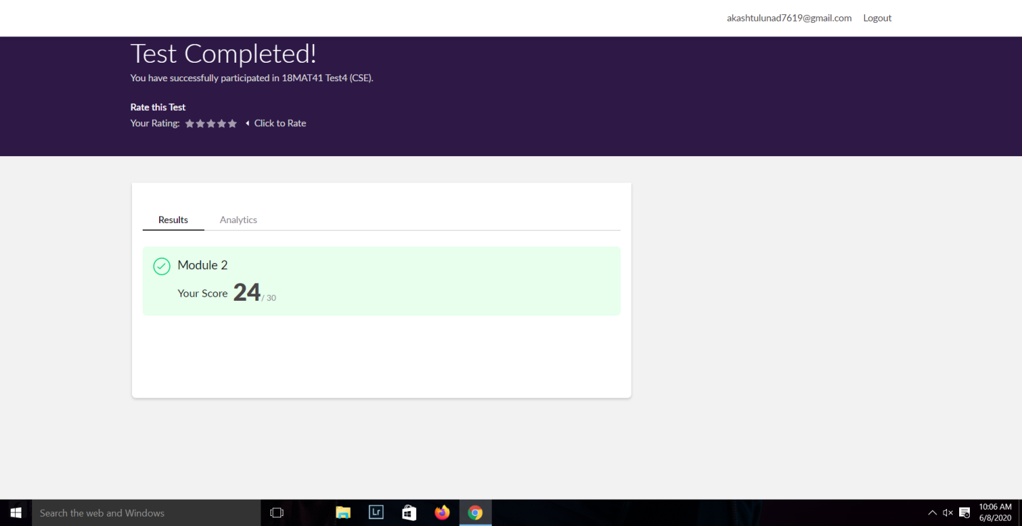

**Online Certification course:**

Name of the course : Cyber security

Duration: 5.5 hours

Certificate provider: great learning

Today I have successfully completed cyber security certification course .Today I learn about introduction to cryptography, secure system design, Threats and Vulnerabilities and what is cyber security . I have written a assessment quiz and successfully received thecertificate

Snap shot:



Snap shot of the certificate:

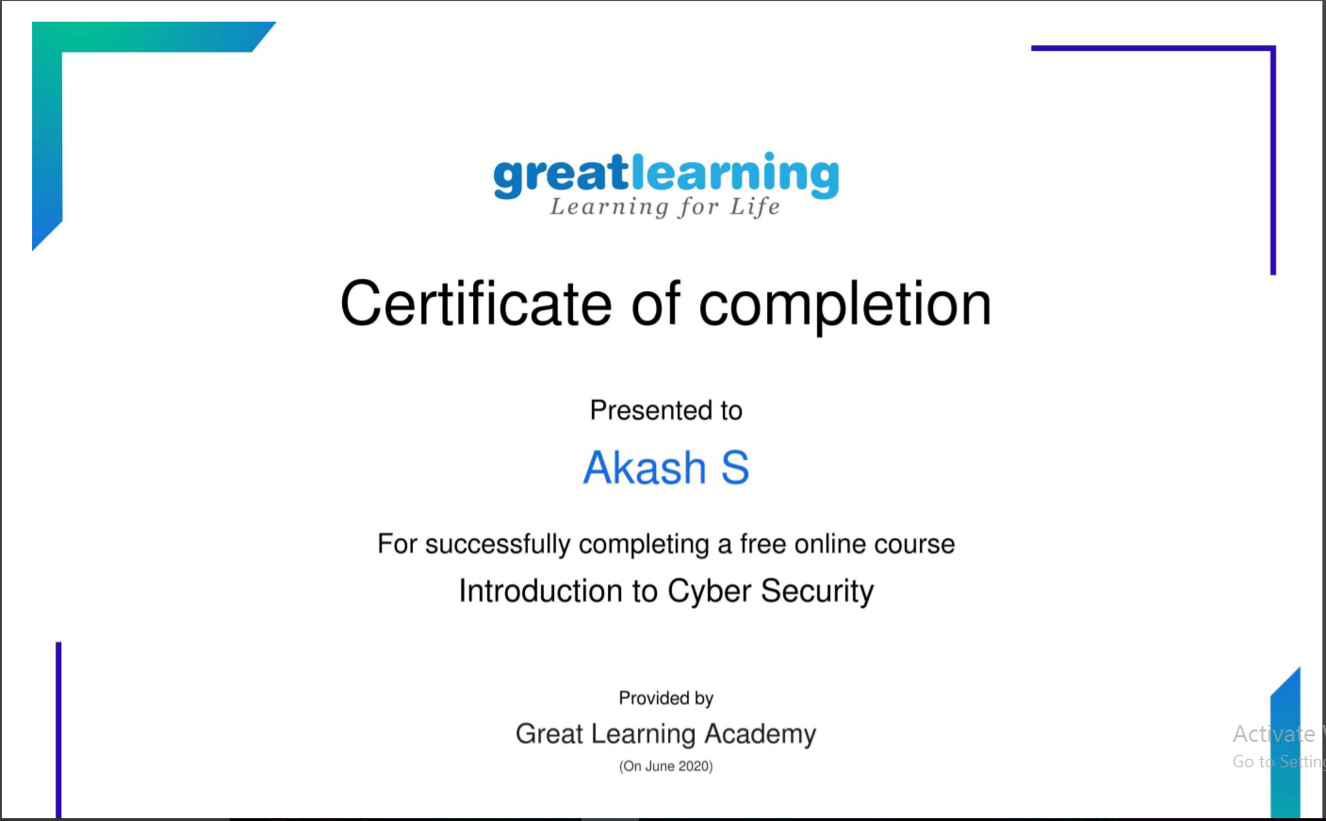

Online Coding summary:

**1.  Write a java program to check weather the given matrix is magic square or not.**

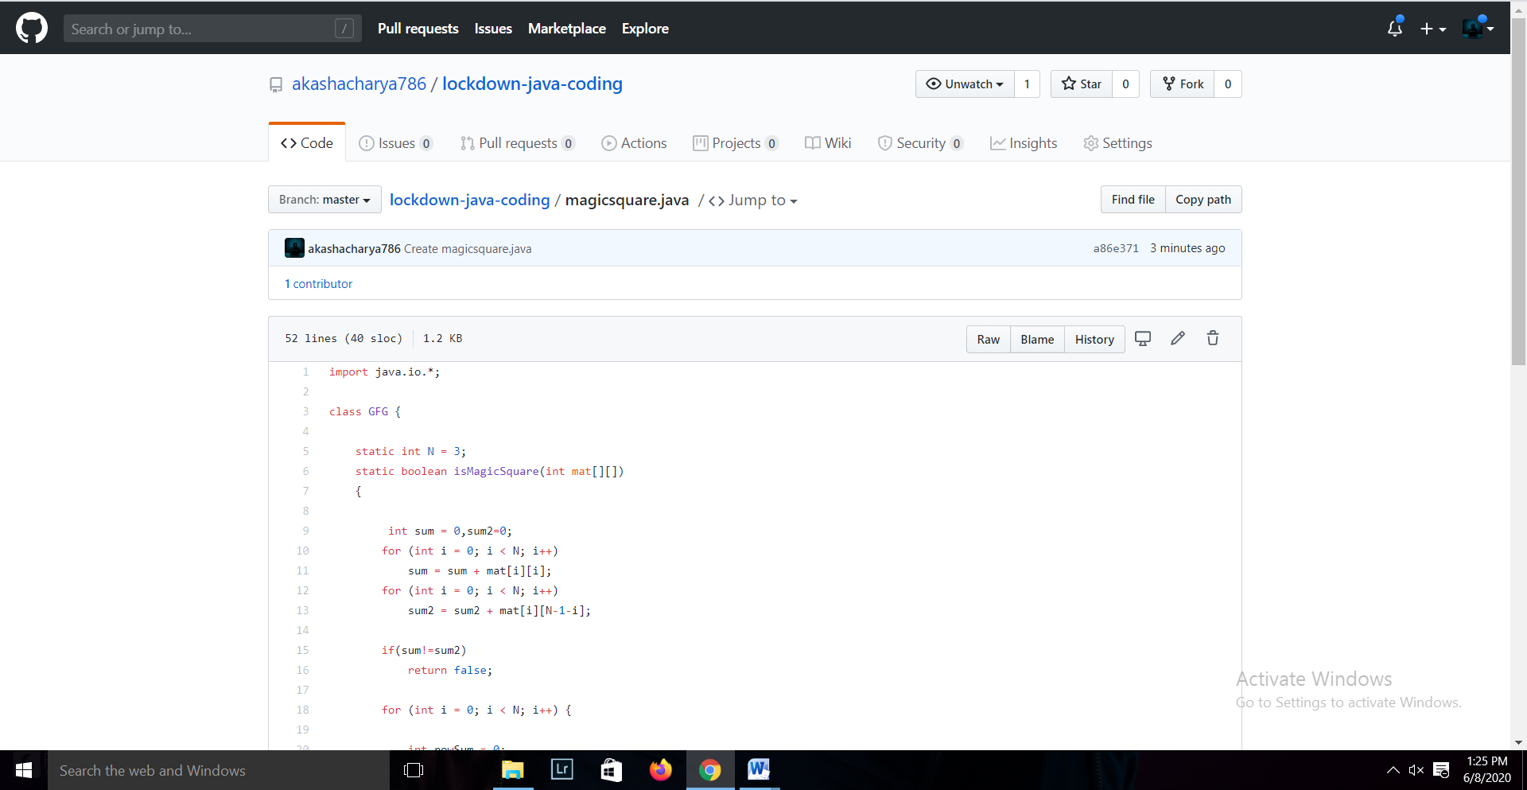

**2. C Program to Generate All the Set Partitions of n Numbers Beginning from 1 and so on**

